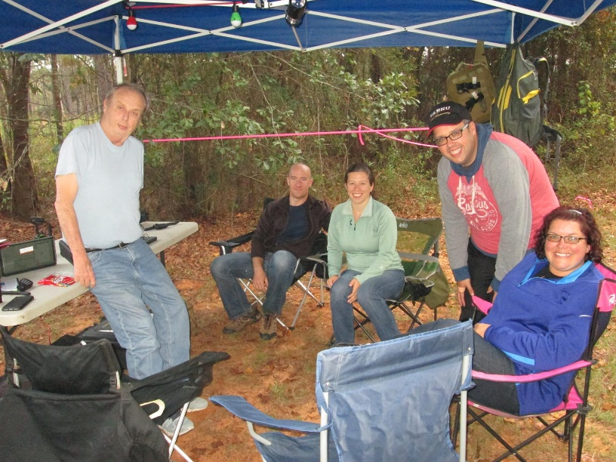

Hurricane Lake North

Steve N4GXX

Jessie KB2OBQ

Hilary

Arc W4CPD

Josie WD4DCL

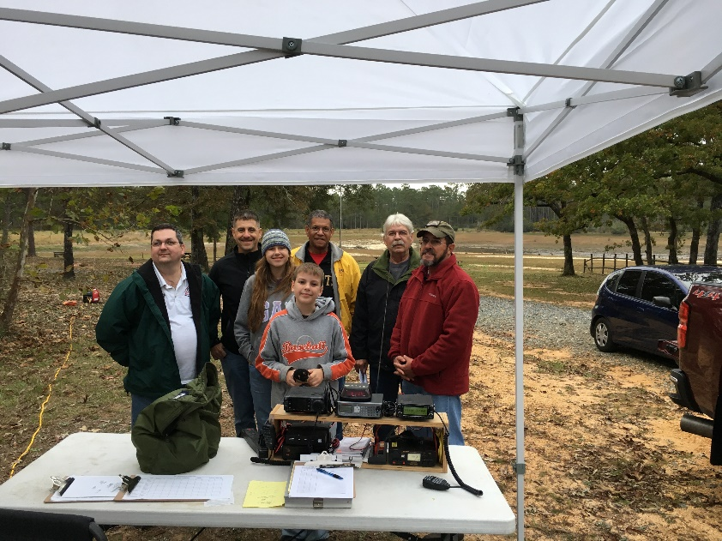

Karick Lake

Richard KE4BFX

Alex KC7MEX

Rich N4DPM

Michael KJ4FNA

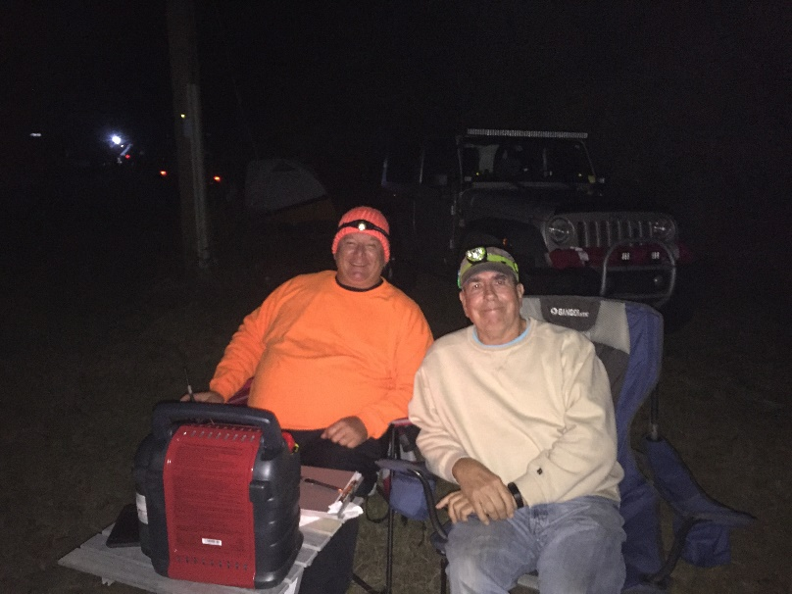

Peaden Bridge

Tom KM4UQB

Tom N9UY

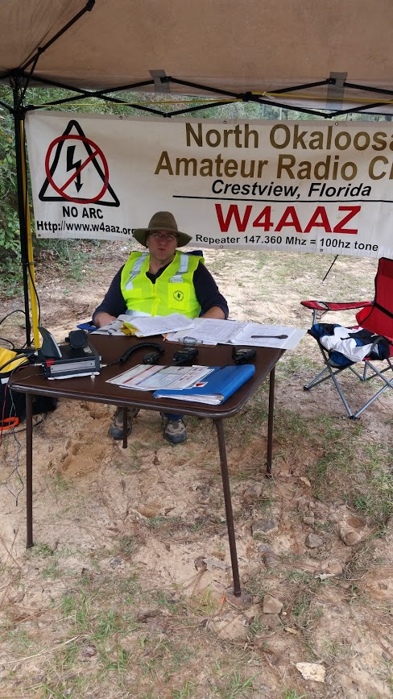

Juniper Creek

Ron KI5FR

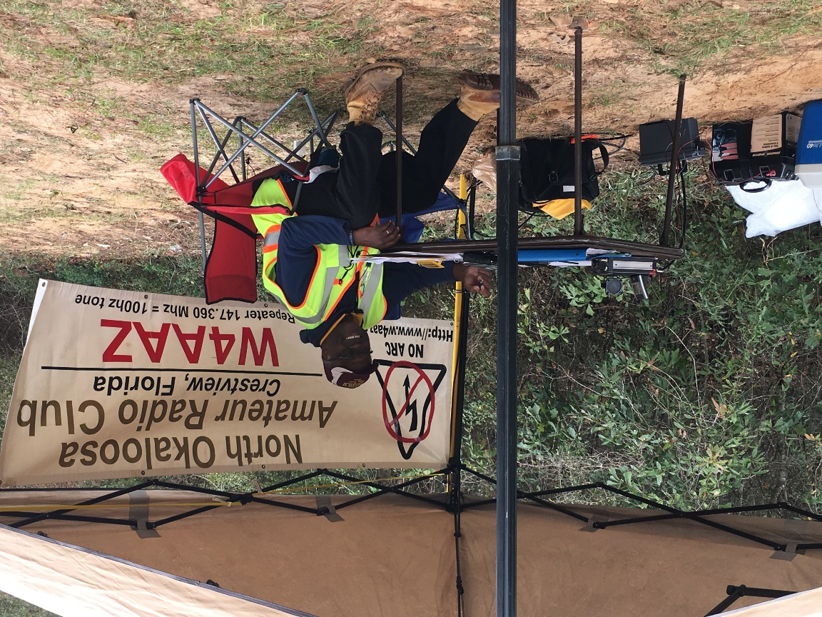

Juniper Creek

Bruce KA5DLV

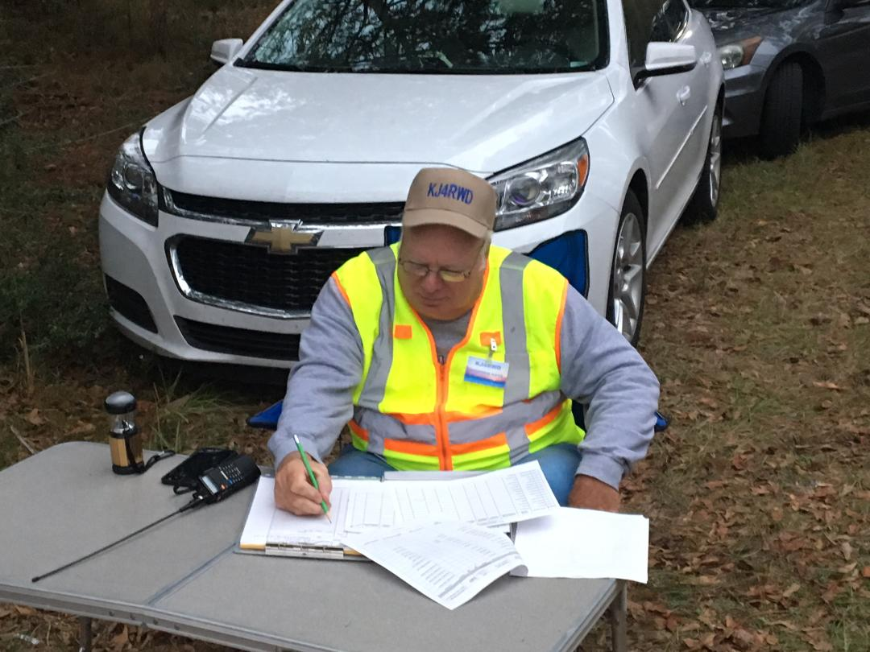

Florida/Alabama State Line

Steve KJ4RWD

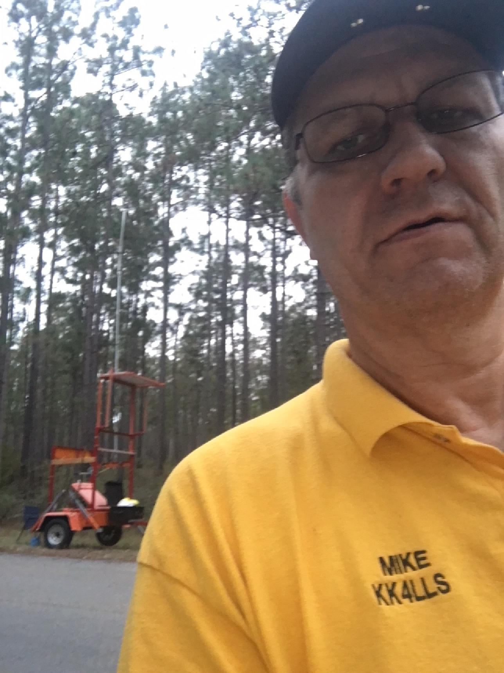

Florida/Alabama State Line

Mike KK4LLS

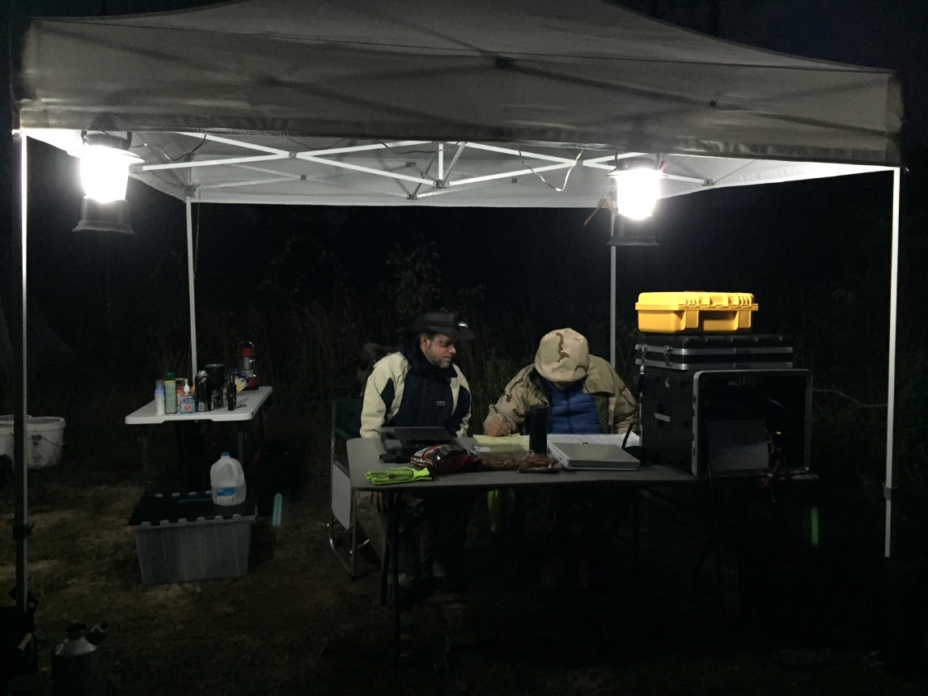

Bear Lake Connector

Len K4KBD

Clint KK4NDU

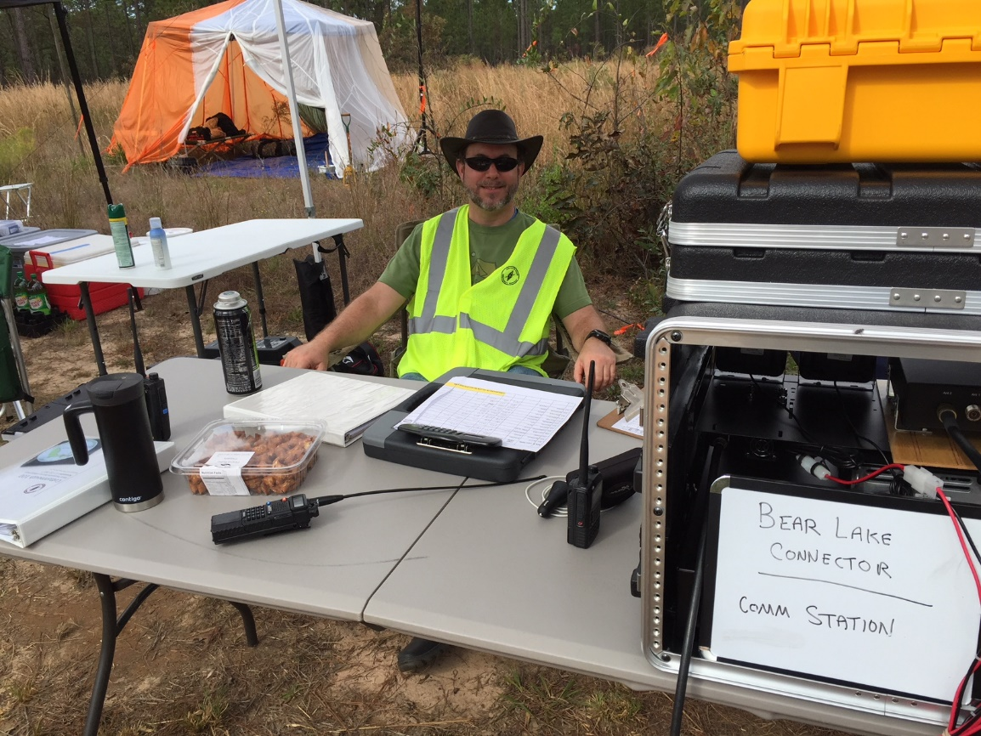

Bear Lake Connector

Len K4KBD

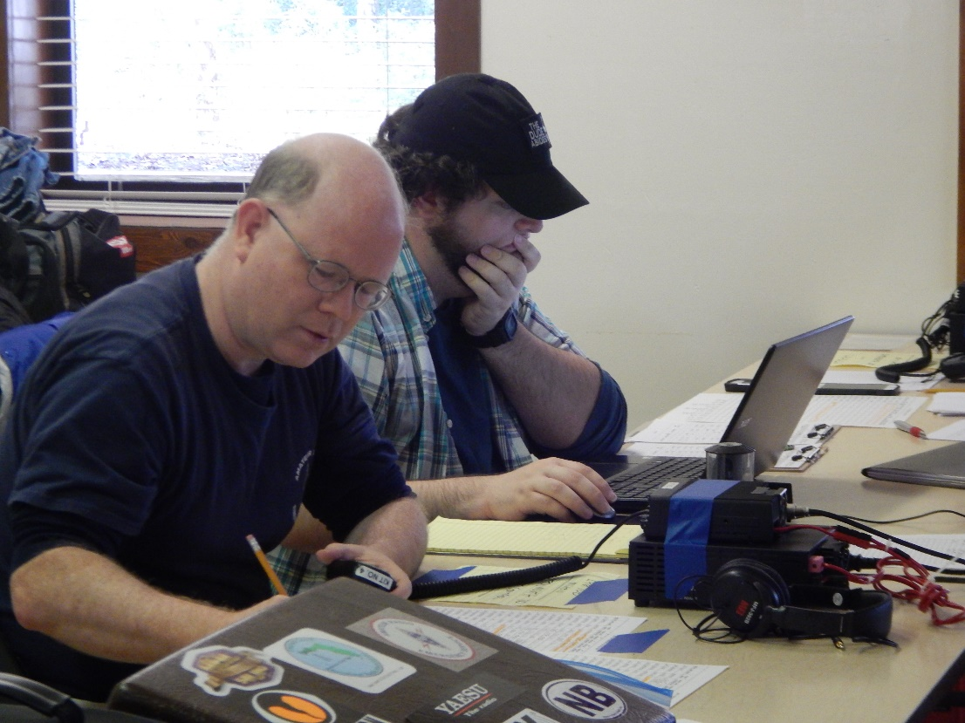

Net Control

Joe KF4DVF

Logan KM4YCJ

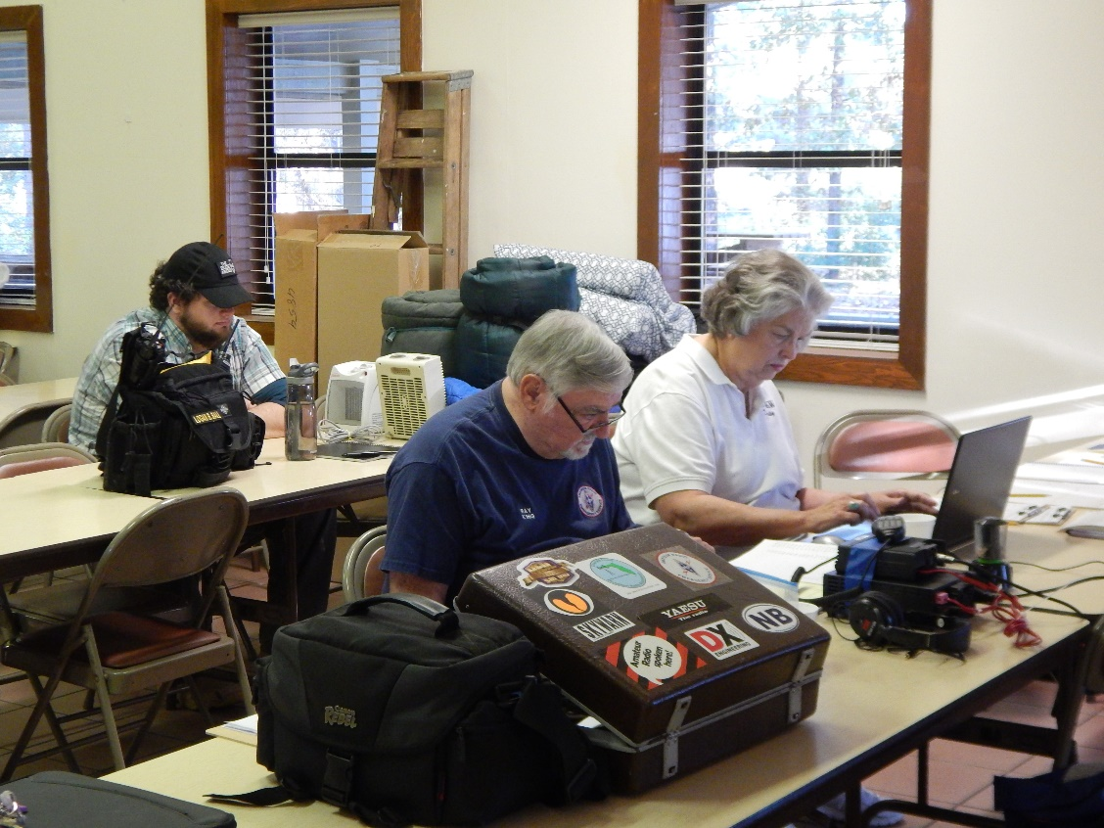

Net Control

Logan KM4YCJ

Ray K1HG

Daisy KT4KW

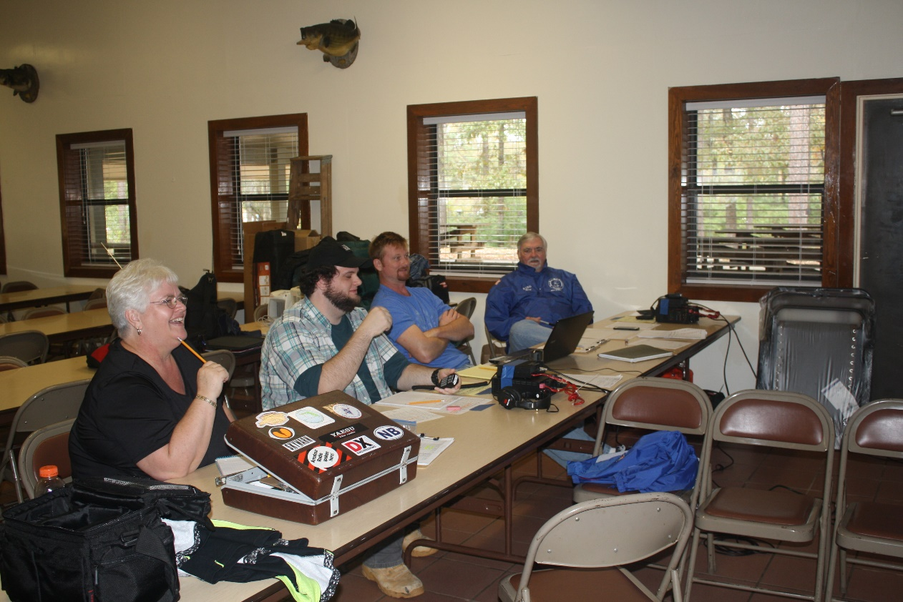

Net Control

Shannon KN4GXR

Logan KM4YCJ

Neil KK4VHX

Ray K1HG

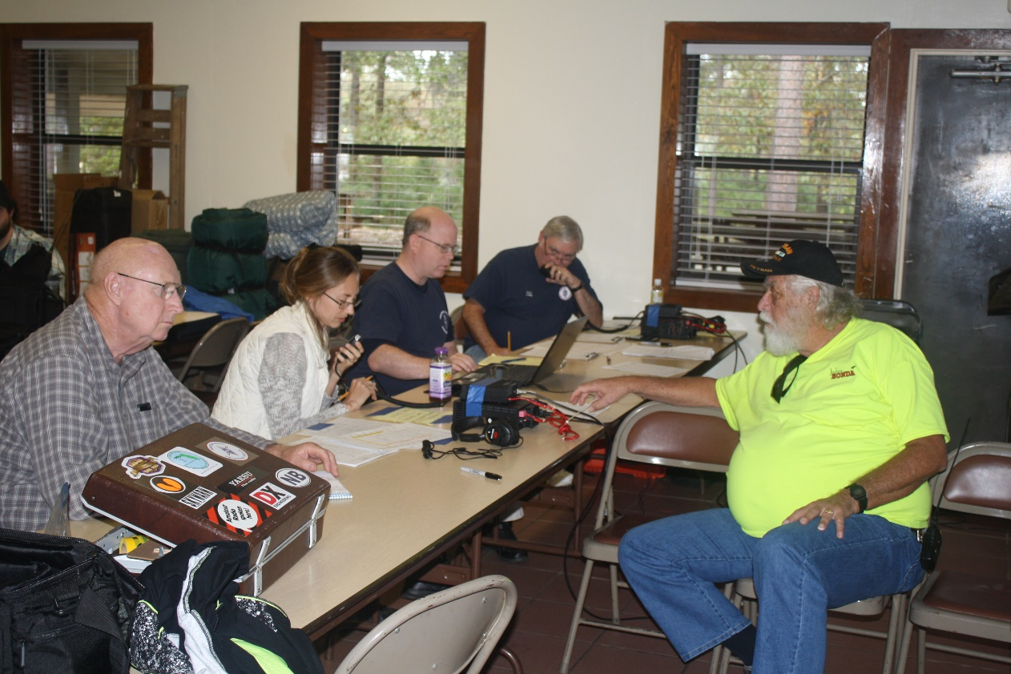

Net Control

Roger KK4QMI

Natalia KN4FVE

Joe KF4DVF

Ray K1HG

Sam WS4SW

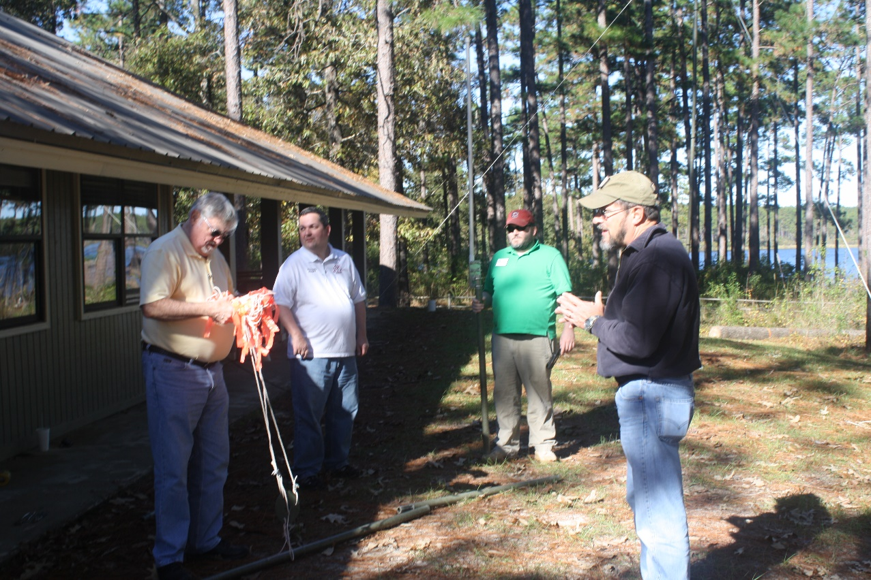

Erecting antennas at Net Control – Bear Lake

Ray K1HG

Richard KE4BFX

Jon KM4QQO

Michael KJ4FNA

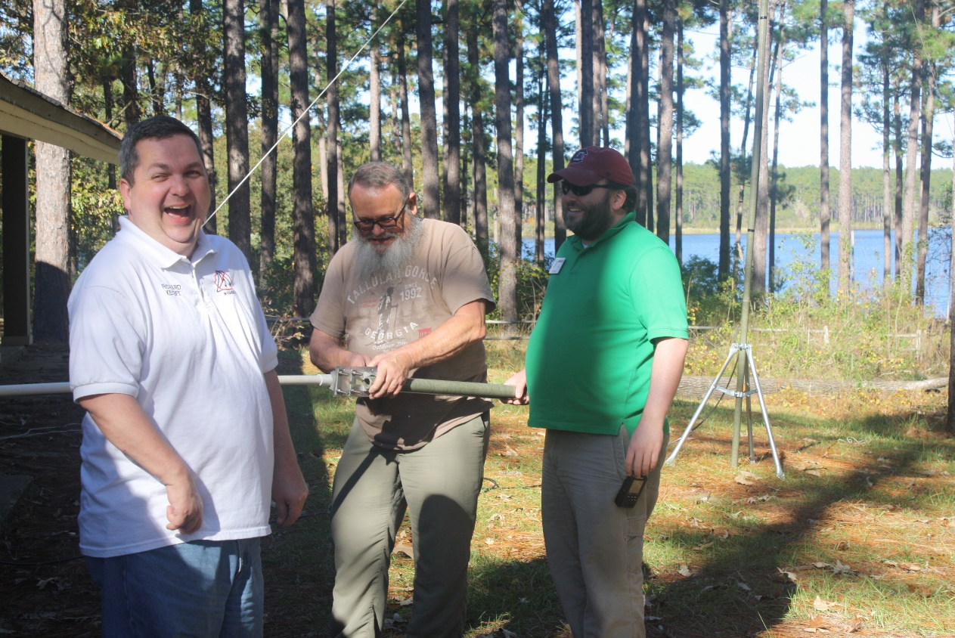

Erecting antennas at Net Control – Bear Lake

Richard KE4BFX

Jack KM4QQN

Jon KM4QQO

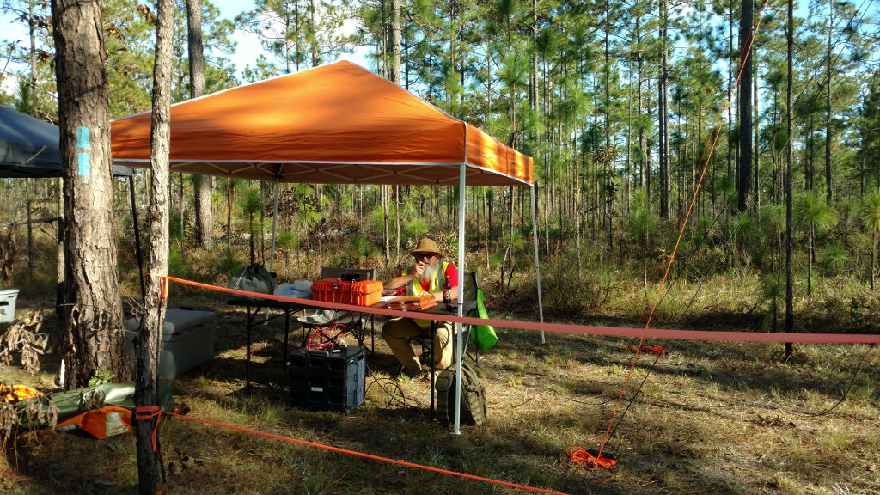

Wiregrass

Jack KM4QQN

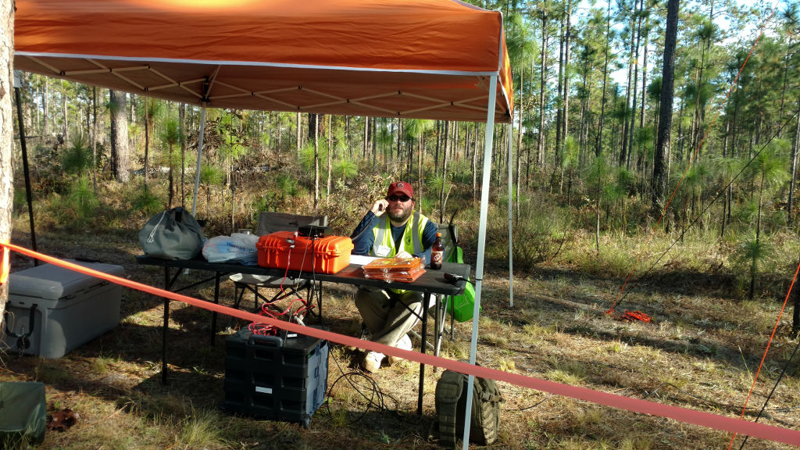

Wiregrass

Jon KM4QQO